Bullets
This is a list of bullet points
This is the latest in cutting edge presentation style
I say so, it must be true
And I know about the repetition, so I’ll say it again
Right, any questions?
Coffee-and biscuits!!!!!
PS Anyone got a photo of a cute cat?

Sporting Equipment
Baseball
Baseball glove
Baseballs
Bats
Basketball
Basketballs
Golf
Golf clubs
Golf balls
Miscellaneous Equipment
Pool
Pool float (small)
Pool float (medium)
Water volleyball kit
Other
Hula hoops
Horseshoes
Sidewalk chalk

Numbering List

Executive Summary
Method of Investigation
Evidence
Conclusions
Introduction
Major Issues
Intended Readers
Name of Commissioner
Boundaries of the Investigation
Scope of the Investigation
Acknowledgements
Terms of Reference
Body
Conclusion
Recommendations

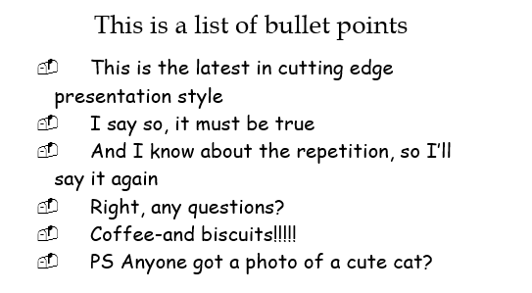
You need to apply bullet and numbering list to the text above so that it become like the pictures below.

